**Web Designing Assignment**

**Term-2**

**Module (CSS and CSS 3) -2**

1. **What are the benefits of using CSS?**

**Ans-**Cascading Style Sheets, or CSS, is the style sheet language for describing how an HTML or XML document is presented. CSS brings several benefits to web development:

**Separation of Concerns**:CSS makes it clear that structure (HTML) and presentation (CSS) of a web page are separate. It also allows for code separations, making maintenance and understanding more effective.

**Consistency**: The appearance of the same website can be designed using CSS. Specifying the styles in a central stylesheet means the same styles are applied to different pages.

**Reusability**: CSS provides the opportunity of using a style with several elements and pages. This ensures the application of classes and IDs to numerous elements and fosters modular design and easy coding.

**Easy Updates:** For example, if you want to change the look of a website, you will only need to update the CSS file without having to change the HTML structure. This eases updates and makes redesign easy**.**

**File Size and Loading Time**: By using CSS in your web pages, you will save on the size of your web pages and thus faster loading times. When loaded, the browser can cache CSS files making it possible to use them without additional downloads for several pages.

**Accessibility**: This makes the sites more accessible because CSS provides a way to control content presentation. For example, you can choose to implement specific styles of speech synthesis, or customize your design for different media.

**Responsive Design**: It is a crucial element involved in the creation of responsive web pages. Media queries and flexible layout techniques ensure that layout of a web-site is re-arranged based on the resolution of the screen of the device a user is using, and thereby improve user experience with different devices.

1. **What are the disadvantages of CSS?**

**Ans-**While CSS is a powerful and widely used styling language for web development, it does come with certain challenges and limitations:

**Browser Compatibility:**The problem arises when various browsers interpret CSS rules differently resulting in inconsistency when displaying a website. In order to achieve cross-browser compatibility, developers often need to write additional code or use browser-specific prefixes.

**Learning Curve:**For instance, CSS might be very steep for beginners, especially for handling sophisticated layouts and complex styling. Understanding how diverse CSS properties combine with each other and with HTML elements takes time and experience.

**Limited Layout Control:**Despite the fact that CSS is mainly intended for styling and layout, it has some inherent drawbacks with regard to complicated layout structures. In some layouts, there might be the need for workarounds or additional technologies like Flexbox or Grid to achieve the desired outcome**.**

**Performance Impact:**Excessive use of CSS, especially with complex selectors and large style sheets, can impact the performance of a website. Bloated stylesheets may result in slower page load times, affecting the user experience.

**No Variables (Pre-CSS3):**In older versions of CSS, there was no native support for variables. This made it challenging to manage and update styles consistently across a large project. However, CSS preprocessors like Sass and Less have since introduced variables.

**Lack of Expressiveness:**CSS is primarily a declarative language, and it may lack the expressiveness and logic needed for more complex behaviors. While CSS has evolved with features like transitions and animations, certain dynamic styling requirements may still be better handled with JavaScript.

**Security Issues:**CSS can be vulnerable to certain security issues, such as cross-site scripting (XSS) attacks when user-generated content is allowed in stylesheets. Proper input validation and sanitization are essential to mitigate these risks.

1. **What is the difference between CSS2 and CSS3?**

**Ans-**CSS (Cascading Style Sheets) is evolving, and the transition from CSS2 to CSS3 brought several new features and improvements. Here are some key differences between CSS2 and CSS3 along with examples:

**Selectors:**

CSS2: CSS2 selectors are less powerful and versatile compared to CSS3. They don't support complex selections and pseudo-elements as extensively.

CSS3: CSS3 introduces more advanced selectors, allowing for more precise targeting of elements. For example, CSS3 supports attribute selectors with substring matching:

/* CSS2 */

a[href$=".pdf"] {

/* Selects links to PDF files */

}

/* CSS3 */

a[href*=".pdf"] {

/* Selects links containing ".pdf" in the href attribute */

}

**Box Model:**

CSS2: The box model in CSS2 is relatively simple, and it doesn't provide as much control over box sizing and layout.

CSS3: CSS3 introduces the box-sizing property, which allows more flexibility in how the box model is calculated. For example:

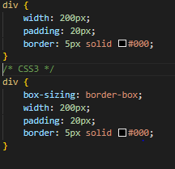

1. **Name a few CSS style components**

**Ans**-CSS style components, often referred to as properties, define various aspects of the presentation of HTML elements. Here are a few CSS style components along with examples:

**Color:**

**Example**: Setting the text color of an element to red.

color: red;

**Font Size:**

**Example**: Setting the font size of text within a paragraph to 16 pixels.

font-size: 16px;

**Margin:**

**Example**: Adding margin space around an element.

margin: 10px;

**Padding:**

**Example**: Adding padding space within an element.

padding: 10px;

**Background Color:**

**Example**: Setting the background color of a div to light blue.

background-color: lightblue;

**Border:**

**Example**: Adding a solid black border to an element.

border: 1px solid black;

**Text Alignment:**

**Example**: Centering the text within a paragraph.

**t**ext-align: center;

**Width and Height:**

**Example**: Setting the width and height of an image.

width: 200px;

height: 150px;

**Display:**

**Example**: Changing the display property to make an element a flex container.

display: flex;

1. **What do you understand by CSS opacity?**

**Ans-**The opacity property specifies the opacity/transparency of an elementThe opacity property can take a value from 0.0 - 1.0. The lower the value, the more transparentExample

img {

opacity: 0.5;

}

1. **How can the background color of an element be changed?**

**Ans-**To change the background color of an HTML element using CSS, you can use the background-color property. Here's an example:

Let's say you have an HTML element, for example, a <div> element, and you want to change its background color to light blue. You can achieve this with the following CSS rule:

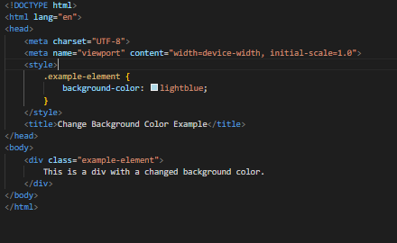

1. **How can image repetition of the backup be controlled?**

**Ans-**The background-repeat property allows you to specify whether and how a background image should repeat both horizontally and vertically. Here's an example:

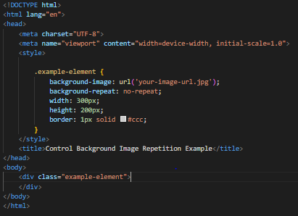

1. **What is the use of the background-position property?**

**Ans-**The background-position property in CSS is used to control the placement of a background image within its containing element. It allows you to specify the starting position of the background image, both horizontally and vertically. The values you can use include keywords, percentages, and length units. Here's an example:

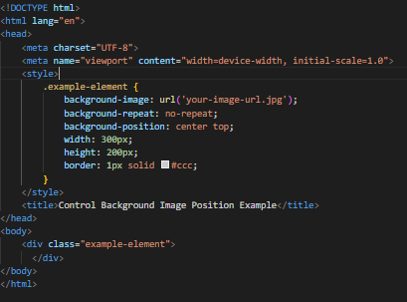

1. **Which property controls the image scroll in the background?**

**Ans-**The background-attachment property specifies whether the background image should scroll or be fixed (will not scroll with the rest of the page):

**Example**

Specify that the background image should be fixed:

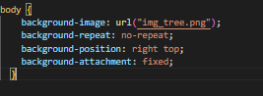

1. **Why should background and color be used as separate properties?**

**Ans-**Using the `background` property and the `color` property separately in CSS provides flexibility and allows for more precise control over the styling of an element. The `background` property is a shorthand property that combines various background-related properties, including `background-color`, `background-image`, `background-repeat`, `background-position`, and `background-size`. Separating `color` and `background` can be advantageous for several reasons:

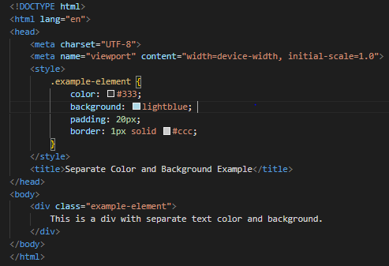

1. **How to center block elements using CSS1?**

**Ans**-CSS Level 1 (CSS1) was the initial version of the Cascading Style Sheets language, and it did not have as many layout capabilities as later versions. Centering block elements in CSS1 was less straightforward compared to modern CSS versions. Here's an example of how you might center a block element horizontally using CSS1:

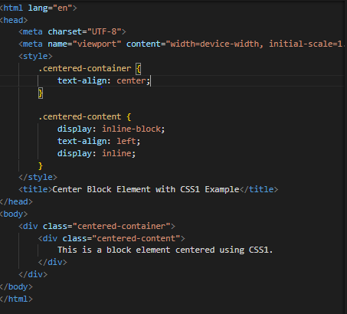

1. **How to maintain the CSS specifications?**

**Ans-**Maintaining CSS specifications involves organizing and documenting your styles to ensure clarity, consistency, and ease of future updates. Here are some best practices and examples for maintaining CSS specifications:

**1. Organize Styles with Comments:**

Use comments to logically divide and label sections of your stylesheet. This helps developers understand the purpose and structure of different style rules.

css

/* ==============================

Header Styles

=============================== */

header {

/* Header styles here */

}

/* ==============================

Navigation Styles

=============================== */

nav {

/* Navigation styles here */

}

**2. Use Meaningful Class and ID Names:**

Choose clear and descriptive names for classes and IDs. This improves readability and makes it easier for others (or yourself) to understand the purpose of each selector.

css

.main-content {

/* Styles for the main content area */

}

#header-logo {

/* Styles for the header logo */

**}**

**3. Create a Style Guide:**

Document your CSS conventions and best practices in a style guide. Include guidelines for naming conventions, indentation, comments, and more. This serves as a reference for developers working on the project.

css

/**

* Style Guide

* ============

*

* 1. Naming Conventions

* 2. Indentation

* 3. Comments

* 4. ...

*/

**4. Use Variables for Reusable Values:**

Define variables for commonly used values such as colors, font sizes, or spacing. This makes it easier to update styles consistently across the entire project.

css

:root {

--primary-color: #3498db;

--font-size-large: 18px;

}

.button {

background-color: var(--primary-color);

font-size: var(--font-size-large);

}

**5. Group Related Properties:**

Group related properties together. For example, keep all box model properties together, typography properties together, etc. This enhances readability and makes it easier to find and modify styles.

css

.box {

width: 200px;

height: 200px;

margin: 10px;

padding: 20px;

border: 1px solid #ccc;

}

**6. Use a CSS Preprocessor:**

Consider using a CSS preprocessor like Sass or Less. Preprocessors provide features like variables, nesting, and mixins, which can make your stylesheets more maintainable and scalable.

scss

// Sass Example

$primary-color: #3498db;

.button {

background-color: $primary-color;

}

1. **What are the ways to integrate CSS as a web page?**

**Ans-**There are several ways to integrate CSS into a web page. Here are the common methods along with examples:

**1. Inline Styles:**

Inline styles are directly applied to individual HTML elements using the style attribute.

html<p style="color: blue; font-size: 16px;">This is a paragraph with inline styles.</p>

**2. Internal Styles (Embedded Styles):**

Internal styles are placed within the <style> element in the HTML document's <head> section.

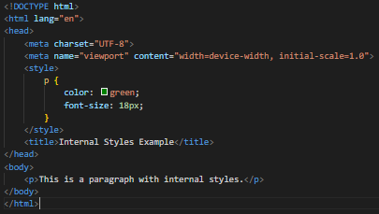

**3. External Styles (Linked Stylesheet):**

External styles are defined in a separate CSS file and linked to the HTML document using the <link> element in the <head> section.

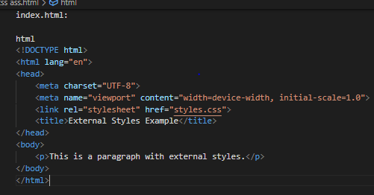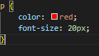

1. **What is embedded style sheets?**

**Ans-**Embedded style sheets, also known as internal style sheets, involve placing the CSS directly within the HTML document using the <style> element in the <head> section. Here's an example:

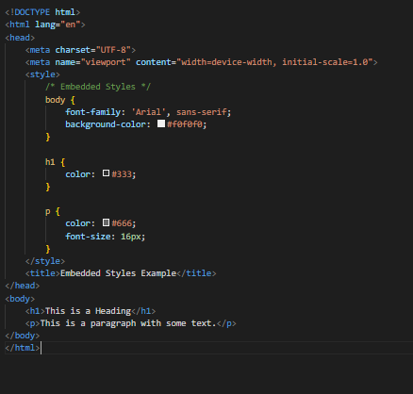

1. **What are the external style sheets?**

**Ans-**External style sheets involve creating a separate CSS file and linking it to an HTML document using the <link> element in the <head> section. This method allows for better organization, reusability, and easier maintenance of styles across multiple pages. Here's an example:

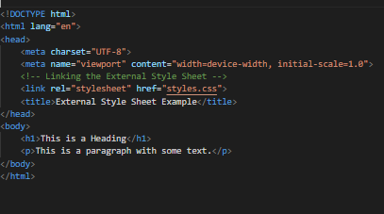

1. **What are the advantages and disadvantages of using external style sheets?**

**Ans-**Using external style sheets in web development has both advantages and disadvantages. Here are some of the key points to consider:

**Advantages:**

**Reusability**:Styles defined in an external style sheet can be reused across multiple HTML pages. This ensures a consistent look and feel throughout the entire website.

**Maintainability:**Centralized styling in an external file makes it easier to manage and maintain. Updates to the styles can be made in one place, affecting all pages that link to the style sheet.

**Consistency**:External style sheets promote consistency in design. By applying the same styles to different pages, you create a unified and professional appearance for your website.

**Faster Page Loading:**Once the style sheet is loaded, it can be cached by the browser. Subsequent page visits may load faster because the styles are already stored locally.

**Disadvantages**:

**Additional HTTP Reques**t:Each external style sheet requires a separate HTTP request, which can marginally slow down the initial page load, especially for small websites where the overhead of additional requests might be noticeable.

**Rendering Blocking**:While the browser is fetching the external style sheet, rendering of the HTML content may be delayed. This is known as render-blocking, and it can affect perceived page load speed.

**Compatibility Issues**:

External style sheets may introduce compatibility issues, especially when the website is viewed offline or in certain development environments where external resources are restricted.

**.**

1. **What is the meaning of the CSS selector?**

**Ans-**There are six type of selectors

1)**Element Selector:**

Selects all instances of a specific HTML element.

css

p {

color: blue;

}

**2)ID Selector:**

Selects a specific element with a given ID attribute.

css

#header {

background-color: #333;

color: white;

}

**3)Class Selector:**

Selects elements with a specific class attribute.

css

.highlight {

font-weight: bold;

color: #ff0000;

}

**4)Child Selector:**

Selects an element that is a direct child of another specified element.

css

ul > li {

list-style-type: square;

}

**5)Pseudo-classes and Pseudo-elements:**

Selects elements based on their state or position.

css

a:hover {

text-decoration: underline;

}

p::first-line {

font-weight: bold;

}

**6)Grouping Selector**:

Groups multiple selectors together to apply the same styles.

css

h1, h2, h3 {

color: #333;

}

1. **What are the media types allowed by CSS?**

**Ans-**CSS (Cascading Style Sheets) allows you to apply styles based on different media types using media queries. Media types represent the characteristics of the targeted output device or display. Here are some common media types allowed by CSS:

**All (Default):**

Applies to all media types. This is the default media type if none is specified.

css

@media all {

/* Styles for all media types */

}

**Screen**:

Applies to devices with a screen, such as computers, tablets, and smartphones.

css

@media screen {

/* Styles for screen devices */

}

**Print:**

Applies when the document is printed.

css

@media print {

/* Styles for printed documents */

}

**Speech:**

Applies to screen readers and other speech synthesizers.

css

@media speech {

/* Styles for speech synthesis */

}

**Aural:**

Deprecated and not widely supported. Intended for devices that read the document out loud.

css

@media aural {

/* Styles for aural devices (deprecated) */

}

**Braille:**

Deprecated and not widely supported. Intended for Braille tactile feedback devices.

css

@media braille {

/* Styles for Braille devices (deprecated) */

}

1. **What is the rule set?**

**Ans-**A "rule set" in the context of CSS (Cascading Style Sheets) refers to a grouping of CSS rules that define the styling properties for a particular HTML element or a group of elements. A CSS rule set consists of a selector and a declaration block. Here's the basic structure of a CSS rule set:

Css

selector {

property1: value1;

property2: value2;

/* More properties and values */

}

Let's break down the components:

**Selector**: The selector is the HTML element or elements to which the style rules should apply. It defines the scope of the rule set. Selectors can be simple, targeting a specific element type (e.g., p for paragraphs), or more complex, using classes (e.g., .my-class) or IDs (e.g., #my-id).

**Declaration Block**: The declaration block is enclosed in curly braces {} and contains one or more property-value pairs. Each property-value pair defines a styling attribute for the selected element(s). Properties specify what aspect of the element's style is being set (e.g., color, font-size, margin), and values determine the specific styling for that property.

Here's a practical example:

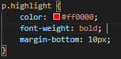

1. **Create Layouts**

**Ans-**Creating layouts in web development involves organizing and positioning HTML elements on a page to achieve a desired structure. CSS is commonly used to style and position these elements. There are different layout techniques, and the choice depends on the design requirements. Here, I'll provide a basic example of creating a simple webpage layout using HTML and CSS.

